**Assignment 2:**

1. Yes there is a warning while compiling.



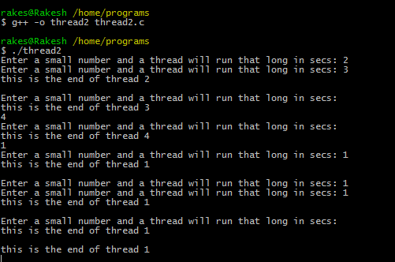

1. No there is no change in the output of both versions.